POTENTIAL BUTTONS FOR THE TREASURE HUNT, IF NEEDED
This would be on the Advent Adventure Home page + wherever else appropriate, I think it should appeal to both kids (age 5+) and adults.

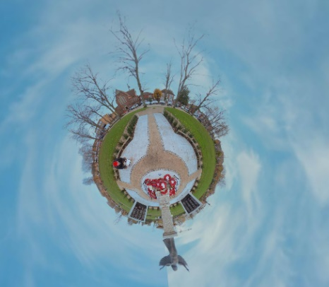
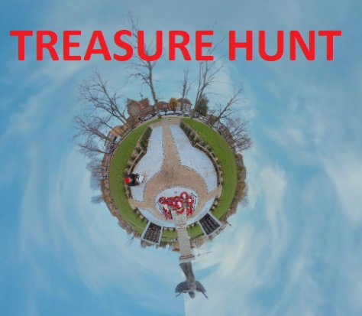

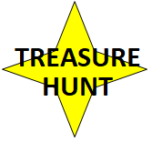

The button would take you to this LANDING PAGE to get some instructions – BEFORE YOU CLICK THROUGH TO THE VIRTUAL TREASURE HUNT

Welcome…
to the Advent Adventure Virtual
TREASURE HUNT!
To go straight to the TREASURE HUNT Click here (https://storage.net-fs.com/hosting/6306700/7/)
To watch the Tutorial Video (Embed this?) Click here (https://www.youtube.com/watch?v=P7_O_ZDc89o)
Objective:
Find the 9 hidden stars. Write down the letter from each star. Unscramble the TREASURE HUNT code word. Send us the code word via the Hope Eastleigh Facebook Page (https://www.facebook.com/connecteastleigh/)
Tips:
The star above the angel is an example, so you know what you’re hunt for!
The stars are all hidden beneath blue buttons. See a blue button? Click on it for reveal the star.
Look carefully all around you. Stars could be hidden anywhere. Where would you hide them?
Enjoy!
Start TREASURE HUNTING Click here (https://storage.net-fs.com/hosting/6306700/7/)

